**Autism Support Companion (MobileAPP)**

**Design Document**

**Version 1.0**



**Group Id: Bc190401150**

**Supervisor Name :** Abdullah Qamar

**Revision History**

|  |  |  |  |
| --- | --- | --- | --- |
| **Date (dd/mm/yyyy)** | **Version** | **Description** | **Author** |
| 4/10/2024 | 1.0 | The Autism Support Companion App is envisioned as a comprehensive digital platform tailored specifically for individuals on the autism spectrum, their caregivers, and therapists. At its core, the app aims to enhance the quality of life for its users by offering a range of supportive features and functionalities. | **Bc190401150** |
|  |  |  |  |
|  |  |  |  |
|  |  |  |  |

**Table of Contents**

1. Introduction of Design Document
2. Entity Relationship Diagram (ERD)
3. Sequence Diagrams
4. Architecture Design Diagram
5. Class Diagram
6. Database Design
7. Interface Design
8. Test Cases
9. **Introduction of Design Document**

A design document helps you explain your design choices to others, especially to your client, showing why your design works well. A design is good if it meets the requirements in a clear and effective way. If any part of the design can't be explained or justified, it may need to be rethought. Design is a crucial step in software development, and this document often includes both images (like screenshots) and written explanations. In this document, we have included an ERD (Entity Relationship Diagram), Sequence Diagram, Class Diagram, Database Design, Interface Design, and Test Cases. The design document explains the system requirements, overall structure, how it works, and how it connects with other systems. Its main goal is to clearly document the software design. Well-documented code is easier to reuse and maintain. It also captures key design choices, such as what each part is responsible for, which helps with performance. Additionally, it supports software integration and testing by describing how different parts of the system connect.

There are different activities of this project that are used in this document are as follow:

* **Entity Relationship Diagram (ERD) :-**

ER diagrams are commonly used in software engineering for relational databases. They are a type of flowchart that shows how different entities are connected in a system. An ER diagram represents entities and their relationships in a visual way. Entities are shown as rectangles, while their properties, called attributes, are shown as ellipses. Diamonds are used to display the relationships between entities.

* **Sequence Diagram:-**

A sequence diagram is a type of interaction diagram that shows how objects communicate with each other and in what order. It illustrates the interaction between objects during a specific process or collaboration.

* **Architecture Design Diagram:-**

An architecture diagram is an important tool for software and application developers. It shows the basic structure of the software or application, divided into different layers. The diagram illustrates how the system interacts with its services and how everything is organized.

* **Class diagram:-**

A class diagram in UML is a type of static diagram that shows the structure of a system by displaying its classes, their attributes, methods, and the relationships between objects. It is a key part of object-oriented modeling and is used for general conceptual modeling of a system.

* **Database design**

Database design shows both the logical and physical structure of a database. It organizes data based on a database model, describing the system’s classes, their attributes, and the relationships between objects. It also involves choosing primary keys and foreign keys for each table.

* **Interface Design**

The interface diagram shows what a system looks like and how its front end is designed. User interface (UI) design is the process of creating these interfaces in software or devices, focusing on appearance and style. Designers strive to make interfaces that are easy to use and enjoyable for users.

* **Test cases**

Finally, test cases are provided in detail. A test case is a set of actions taken on a system to check if it meets the software requirements and works correctly.

1. **Entity Relationship Diagram (ERD)**

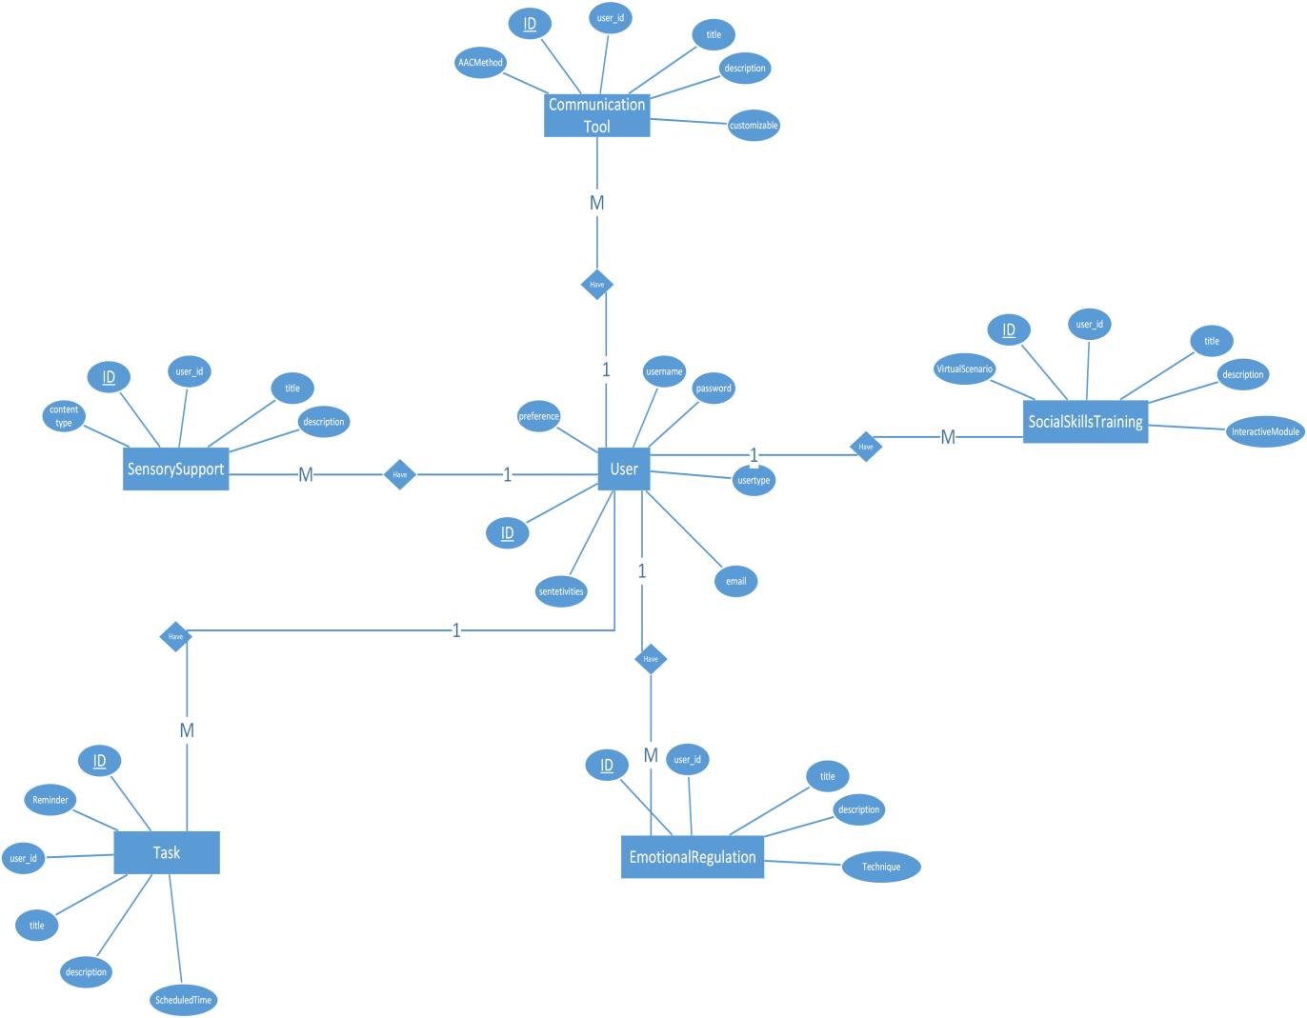

1. **Sequence Diagrams**

User Register and Login

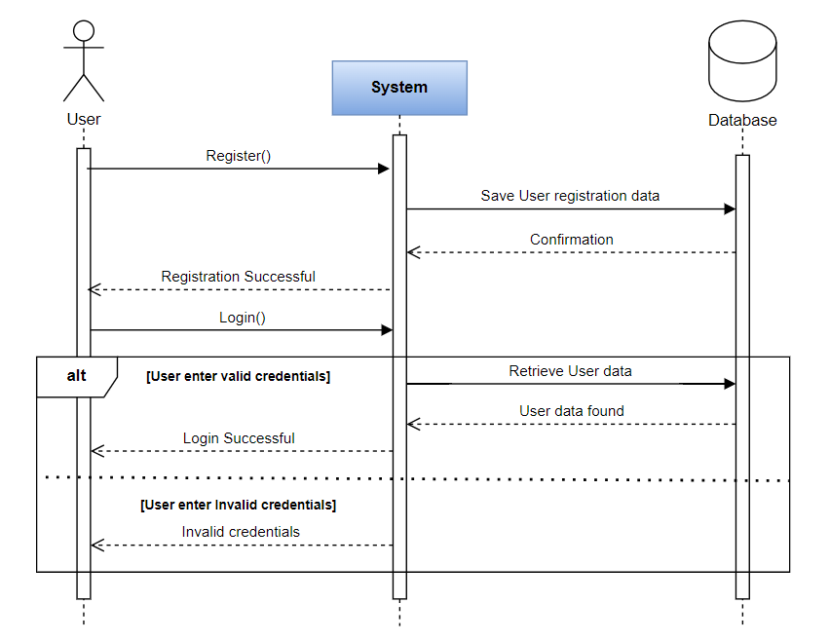

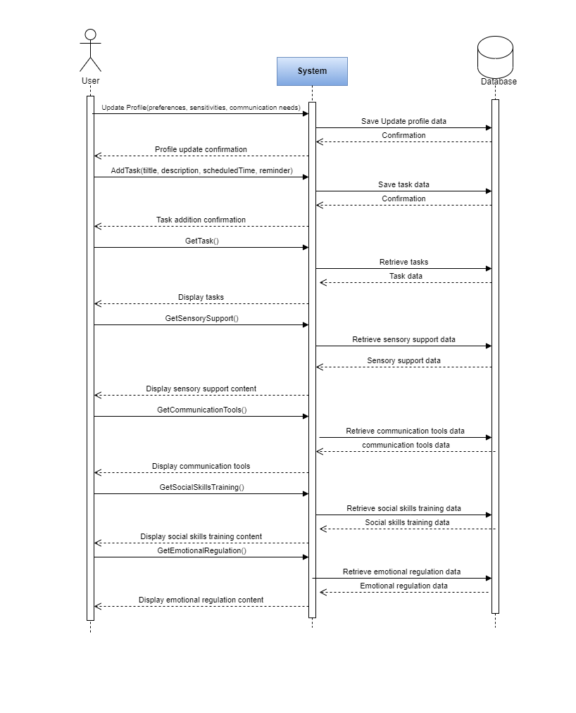

1. **Architecture Design Diagram**

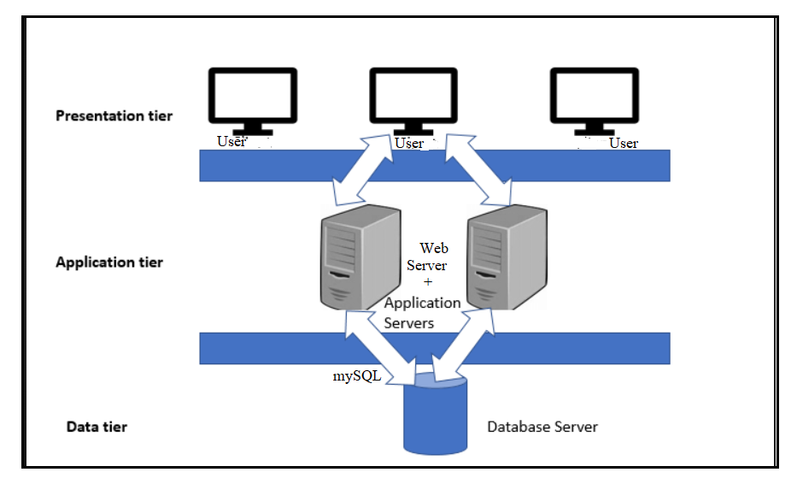

1. **Class Diagram**

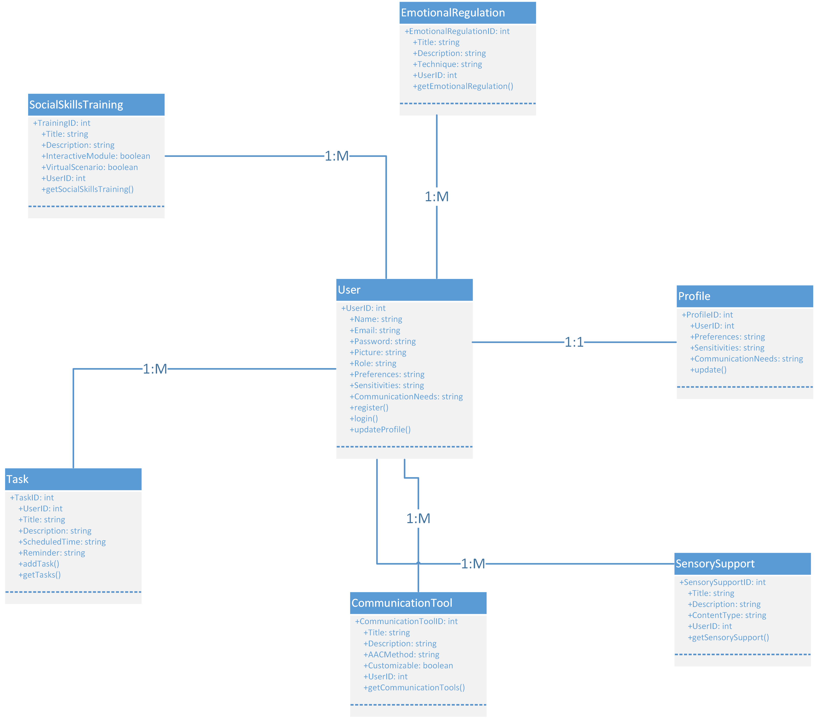

1. **Database Design**

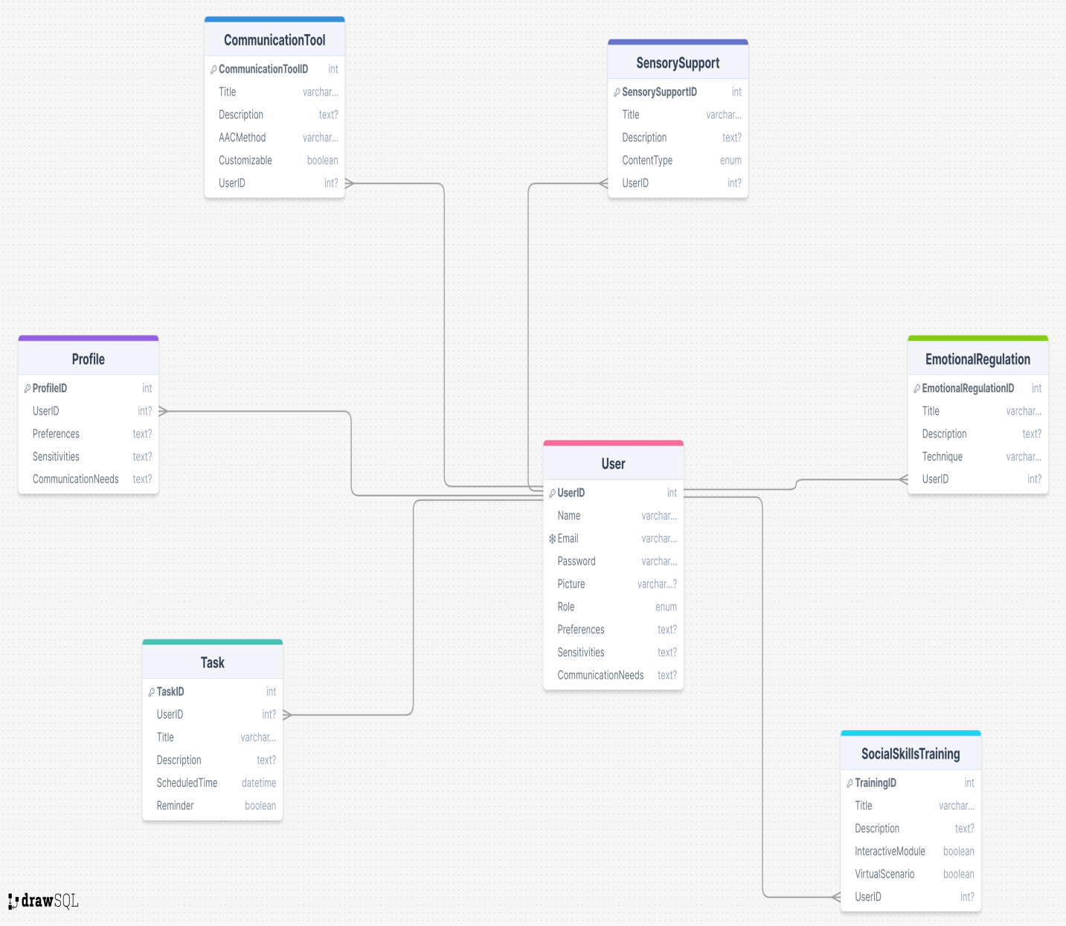

1. **Interface Design**

Login.

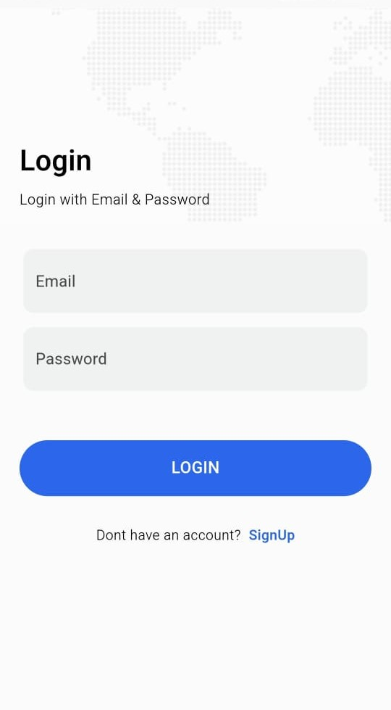

Signup

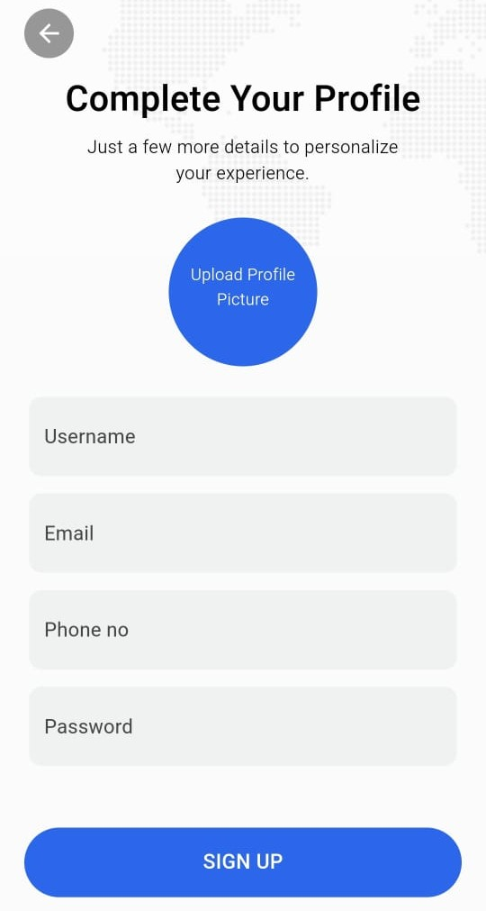

1. **Test Cases**

**Test Case TC_01**

|  |  |
| --- | --- |
| **Heading** | **Description** |
| **Test Case ID** | TC_01 |
| **Test Case Title** | User Registration |
| **Preconditions** | The user is on the registration page. |
| **Actions** | 1. Enter name, email, password, and picture. 2. Click the "Register" button. |
| **Expected Results** | The user account is created, and a confirmation message is displayed. |
| **Tested By** | BC190401150 |
| **Result** | Pass |

**Test Case TC_02**

|  |  |
| --- | --- |
| **Heading** | **Description** |
| **Test Case ID** | TC_02 |
| **Test Case Title** | User Login |
| **Preconditions** | The user is on the login page. The user has already registered. |
| **Actions** | 1. Enter valid email and password. 2. Click the "Login" button. |
| **Expected Results** | The user is logged in successfully and redirected to the dashboard. |
| **Tested By** | BC190401150 |
| **Result** | Pass |

**Test Case TC_03**

|  |  |
| --- | --- |
| **Heading** | **Description** |
| **Test Case ID** | TC_03 |
| **Test Case Title** | Profile Update |
| **Preconditions** | The user is logged in. The user is on the profile update page. |
| **Actions** | 1. Update preferences, sensitivities, and communication needs. 2. Click the "Save" button. |
| **Expected Results** | The profile is updated successfully, and a confirmation message is displayed. |
| **Tested By** | BC190401150 |
| **Result** | Pass |

**Test Case TC_04**

|  |  |
| --- | --- |
| **Heading** | **Description** |
| **Test Case ID** | TC_04 |
| **Test Case Title** | Add Task |
| **Preconditions** | The user is logged in. The user is on the task management page. |
| **Actions** | 1. Enter task title, description, scheduled time, and reminder. 2. Click the "Add Task" button. |
| **Expected Results** | The task is added successfully, and a confirmation message is displayed. |
| **Tested By** | BC190401150 |
| **Result** | Pass |

**Test Case TC_05**

|  |  |
| --- | --- |
| **Heading** | **Description** |
| **Test Case ID** | TC_05 |
| **Test Case Title** | View Tasks |
| **Preconditions** | The user is logged in. The user has added tasks. |
| **Actions** | 1. Navigate to the task management page. 2. View the list of tasks. |
| **Expected Results** | The tasks are displayed correctly. |
| **Tested By** | BC190401150 |
| **Result** | Pass |

**Test Case TC_06**

|  |  |
| --- | --- |
| **Heading** | **Description** |
| **Test Case ID** | TC_06 |
| **Test Case Title** | Access Sensory Support |
| **Preconditions** | The user is logged in. The user is on the sensory support page. |
| **Actions** | 1. Click on sensory support content. |
| **Expected Results** | The sensory support content is displayed. |
| **Tested By** | BC190401150 |
| **Result** | Pass |

**Test Case TC_07**

|  |  |
| --- | --- |
| **Heading** | **Description** |
| **Test Case ID** | TC_07 |
| **Test Case Title** | Access Communication Tools |
| **Preconditions** | The user is logged in. The user is on the communication tools page. |
| **Actions** | 1. Click on communication tool content. |
| **Expected Results** | The communication tool content is displayed. |
| **Tested By** | BC190401150 |
| **Result** | Pass |

**Test Case TC_08**

|  |  |
| --- | --- |
| **Heading** | **Description** |
| **Test Case ID** | TC_08 |
| **Test Case Title** | Access Social Skills Training |
| **Preconditions** | The user is logged in. The user is on the social skills training page. |
| **Actions** | 1. Click on social skills training content. |
| **Expected Results** | The social skills training content is displayed. |
| **Tested By** | BC190401150 |
| **Result** | Pass |

**Test Case TC_09**

|  |  |
| --- | --- |
| **Heading** | **Description** |
| **Test Case ID** | TC_09 |
| **Test Case Title** | Access Emotional Regulation |
| **Preconditions** | The user is logged in. The user is on the emotional regulation page. |
| **Actions** | 1. Click on emotional regulation content. |
| **Expected Results** | The emotional regulation content is displayed. |
| **Tested By** | BC190401150 |
| **Result** | Pass |